

**CBIEV Web Portal**

**For**

**Centre of Business Incubation and Entrepreneurial Ventures (CBIEV)**

**Date:** 23 September 2019

**Document Version:**

0.1-Draft

Contents

1. Introduction 3

1.1. Purpose of the document 3

1.2. Scope 3

2. System Overview 3

2.1. System Characteristics 3

2.2. System Architecture 4

2.2. System Requirement 5

3. System Design Consideration 5

3.1. Assumption 5

3.2. Constraint 5

3.3. Risks 6

3.4. Strategies 6

4. System Design Standard 6

4.1. Naming Convention 7

4.2. Programming Standard 7

5. System Software Design 7

5.1. Software Architecture 7

5.2. Functional Requirement 7

5.3. Non-Functional Requirement 8

5.4. Software Detail Design 9

5.5. Database Design 16

6. Future Upgrade/Consideration 17

7. Development Environment/Deployment 17

7.1. Software Environment 17

7.2. Installation Guide 17

8. Revision History 19

1. Introduction  
   Centre of Business Incubation and Entrepreneurial Ventures (CBIEV) one of the centre in Tunku Abdul Rahman College University (TAR UC) . The centre was established in 2018. Their role is to facilitate and promote the culture of Entrepreneurship by providing various services such as idea/project consultancies, mentorship and funding.
   1. Purpose of the document  
      The purpose of the writing of this document is to document and tracks all the necessary information required to accurately define the requirements and system designs in order to provide system developer a comprehensive guidance and explanation on the nature the system. This document shall incrementally and iteratively produce and update over the course of system development.
   2. Scope  
      The purpose of proposed system is to digitalize the day-to-day operation of CBIEV. Currently, majority of the operations are performed manually and un-timely. In order to complete a task or mission, it would consume an abundance of time and effort. Hence, the current method of operation is costly and inefficient. Hence, ‘CBIEV Web Portal’, a web-based automated web application is proposed in order to overcome said problems. The proposed solution will equip with features and functions to assist in CBIEV daily operation. The proposed solution shall extend the operation efficiency of CBIEV. After a few meetings with CBIEV, the major functionalities at this initial stage were revealed. The system shall be able to automate and reduce cost of daily operations. Some of the major functionalities requested by the client are as follow:

* Online Registration
* Automated Registration Approval
* Automated Notification

# System Overview

## System Characteristics

* + 1. Low Number of Concurrent User

The heavy users for the application are CBIEV Staff. They will be using the application in a much frequent manner for day-to-day departmental operations. The other users such as students and staff from other departments or faculties are most likely to access the application as needed.

* + 1. Security Features to protect Confidential Data

CBIEV operations involve collection of confidential information or data from various stakeholder. Hence, it is crucial to protect such information and data from potential threat such as data leak, unauthorized access and cross-site scripting. A comprehensive data protection shall be implement into the application

* + 1. Highly Scalable in the future  
       The nature of CBIEV
    2. Easily Maintainable

The application shall design to ease up the maintenance work as simple as possible.

* + 1. User Friendly

Most of the users for this application can be considered as new user or first-time user. They have never interacted with similar type of application. Hence, sufficient and proper guidance, hints and instruction are recommended.

* + 1. Highly Accessible

The users or stakeholders who will be using this application is highly diversified. Internally from students to staff of TAR UC, externally, graduated or industrial experts. The system is expected to provide access to those users anytime and anywhere.

* + 1. Data/Information Accuracy

The data and information collected will required periodic update in order to ensure data integrity. Data integrity is critical in order to prevent complex error in the future.

* 1. System Architecture

The proposed application will be based upon a client-server architecture. This proposed architecture is tailored for ‘CBIEV web portal’ use cases. This can be justified by analyse the advantages provided by said architecture in various view point.

* Accessibility  
  In Client-Server Architecture, wide variety of clients will be able to connect and access the application to the server with no platform restriction. The accessibility also not restricted by anywhere and anytime, since the server will be running without downtime.
* Centralization  
  The Client-Server architecture only require physical server to be located at single location. The server will responsible to various task such as authorizations, data processing and web storage.
* Scalability  
  In a Client-Server setup, one may add new resources in the form of hardware and software without major interruption to the application. System or server upgrade can be done by making necessary and minimal changes.
* Security  
  Sever in Client-Server architecture will contain a better access control and resource to enforce security policies across multiple client platform. Hence, system accessibility is controlled and monitored. Once a proper security features such as authentication and authorization implemented in the server, only authorized users will gain access or manipulate the data.

Despite the advantages mentioned above, Client-Server architecture does have some disadvantages. Some of them were as follow:

* Network Congestion  
  When there are frequent simultaneous client request in a period of time, server will become overload. Once a server overloaded, the network congestion may form and to worst, server may break-down and cause loss of data.
* Lack of Robustness  
  Client and Server architecture cannot afford to have a server failure. If a server failure occurs, client requests are not processed and accomplished. Leaving client received zero response from the server.

## System Requirement

* + 1. Hardware Requirement
    2. Software Requirement

# System Design Consideration

# Assumption

Provide a list /description of assumption made during requirements gathering and documentation. These may concern issues such as: related: software or hardware, end-user characteristics and possible and/or probable changes in functionalities

|  |  |  |
| --- | --- | --- |
| Assumptions | Description |  |
|  |  |  |
|  |  |  |
|  |  |  |
|  |  |  |
|  |  |  |
|  |  |  |
|  |  |  |
|  |  |  |
|  |  |  |

# Constraint

This section should describe the constraints associated with the system design, Constraints are the result of various conditions beyond the scope of the project that affect and limit the system design. These may due to hardware, software, business processes, organizational/industry standard, or other conditions which affect the system design. This section should provide a description of what the constraints are and how they affect or limit the system design

|  |  |  |
| --- | --- | --- |
| Constraint | Description |  |
| Approval Process Changes | The approval process may undergo requirement changes due to decision made by management level. |  |
|  |  |  |
|  |  |  |
|  |  |  |
|  |  |  |
|  |  |  |
|  |  |  |
|  |  |  |
|  |  |  |

# Risks

Identify any risks or roadblocks which may impact cycle/project delivery and proposed mitigation strategic

|  |  |  |
| --- | --- | --- |
| Risks | Description |  |
|  |  |  |
|  |  |  |
|  |  |  |
|  |  |  |
|  |  |  |
|  |  |  |
|  |  |  |
|  |  |  |
|  |  |  |

# Strategies

* Describe any design decision or strategies that affect the overall organization of the system.
* Describe the reasoning for each decision/strategy and how priorities were balanced or traded-off
* Describe significant alternatives that were considered and the reasons for rejecting them

Design Decision

* Use of particular tool or library
* Future plans for extending or enhancing the system
* Error detection and recovery
* Concurrency
* Resource Management

|  |  |  |
| --- | --- | --- |
| Strategic | Description |  |
|  |  |  |
|  |  |  |
|  |  |  |
|  |  |  |
|  |  |  |
|  |  |  |
|  |  |  |
|  |  |  |
|  |  |  |

# System Design Standard

To ensure consistency and simplicity in the code, several convention is followed strictly and apply into the source code. For info, Laravel framework follows the PR-0 and PR-1 coding standard. Other than that, they have also implement several other standards for references.

## Naming Convention

In Laravel, all the function or method name are declared in camelCase style. The naming convention for variable is also in camelCase style.

## Programming Standard

Laravel does implement some programming standard of their own. The standards are shown in table below.

|  |  |
| --- | --- |
| No | Standard |
| 1 | Functions and control structures must use Allman style braces. |
| 2 | Indent with tabs, align with spaces. |

# System Software Design

## Software Architecture

## Functional Requirement

* + 1. Online Registration
       1. TAR UC Student shall be able to register a project using online registration

form.

* + - 1. TAR UC Staff shall be able to register a iSpark project using online

registration form.

* + - 1. TAR UC Alumni shall be able to register a iSpark project using online

registration form.

* + - 1. The registration form shall allow registrant to add or reduce number of

member

* + - 1. The registration form shall allow registrant to add or reduce number of

supervisor

* + - 1. TAR UC Staff shall be able to register as iSpark Mentor using online

registration form.

* + - 1. Industry person shall be able to register as iSpark Mentor using online

registration form.

* + - 1. TAR UC Alumni shall be able to register as iSpark Mentor using online

registration form.

* + - 1. Companies shall be able to register as iSpark Investor using online

registration form.

* + - 1. Registrant shall receive a confirmation email notification after a successful

registration

* + - 1. CBIEV shall receive notification after a successful registration
      2. The registration forms’ input field must be validated at client side before

submit to server

* + - 1. The registration forms’ input field must be validated at server side before

save into database.

* + 1. Registration Approval Process
       1. Each project registration shall undergo an approval process to obtain

approval

* + - 1. Each internal mentor registration shall undergo an approval process to

obtain approval.

* + - 1. Each external mentor registration shall undergo an approval process to

obtain approval.

* + - 1. Each investor registration shall undergo an approval process to obtain

approval.

* + - 1. CBIEV staff shall be able to terminate approval process at all stage.
      2. CBIEV staff shall be able to resume terminated approval process.
      3. CBIEV staff shall be able to hold an approval process at all stage.
      4. CBIEV staff shall be able to view the progress of an approval process
      5. CBIEV staff shall be able to generate report regarding approval process.
    1. System Automated Approval Process
       1. The system shall be able to initialize approval process for any registration

with CBIEV staff input.

* + - 1. The system shall be able to automatically send email invitation for

recommendation and approval to person involved.

* + - 1. Invited person shall be able to recommend registration using online

recommendation form

* + - 1. The recommendation form shall be validated.
      2. Invited person shall be able to approve registration using online approval

form.

* + - 1. The approval form shall be validated.
      2. The system shall be able to send notification to CBIEV staff when there is a

submitted recommendation

* + - 1. The system shall be able to send notification to CBIEV staff when there is a

submitted approval.

* + - 1. The system shall be able to automatically process an expired

recommendation.

* + 1. Registration Management
       1. CBIEV staff shall be able to view list of registration.
       2. CBIEV staff shall be able to view a registration in details
       3. CBIEV staff shall be able to deregister any registration
       4. CBIEV staff shall be able to modify registration details
    2. System Access Control
       1. Users must be logged in in order to use the system.
       2. Users shall be able to reset password.
       3. CBIEV staff shall be able to manage all types of account in the system.
       4. CBIEV staff shall be able to manage the access control of the system.

## Non-Functional Requirement

* + 1. Availability
       1. The application shall be available and accessible anywhere and anytime

without platform and hardware constraint

* + 1. Auditable
       1. All transactions shall be audited for future references.
    2. Capacity
       1. The data collected shall persist permanently at all time, no matter during

system runtime or downtime

* + 1. Integrity
       1. Data integrity is strictly enforcing in order to ensure data collected is always

update-to-date and accurate.

* + - 1. Information integrity is strictly enforcing in order to assure the accuracy and

reliability for decision making

* + 1. Maintainability
       1. The application shall be easily maintainable in the future by future

developer.

* + - 1. The coding and structure shall be easy-to-read by enforcing coding standard

such as refactoring and unified coding style

* + 1. Reliability
       1. The application shall be able to run at all time without errors.
       2. The application shall be able to produce result with high accuracy.
       3. The application shall be able to recover from failure with minimal time

required.

* + 1. Scalability
       1. The system shall be able to scale either vertically or horizontally easily in the

future with minimal configuration required

* + 1. Security
       1. Proper security measures such as timeout, password requirement and

access control shall be implemented to prevent data leaks and protect data

from anonymous access.

* + 1. Usability
       1. The user interface shall be easy to understand and comfortable to users.
       2. All the interface shall be standardized and consistency in term of designs

and languages.

## Software Detail Design

* + 1. System Modules

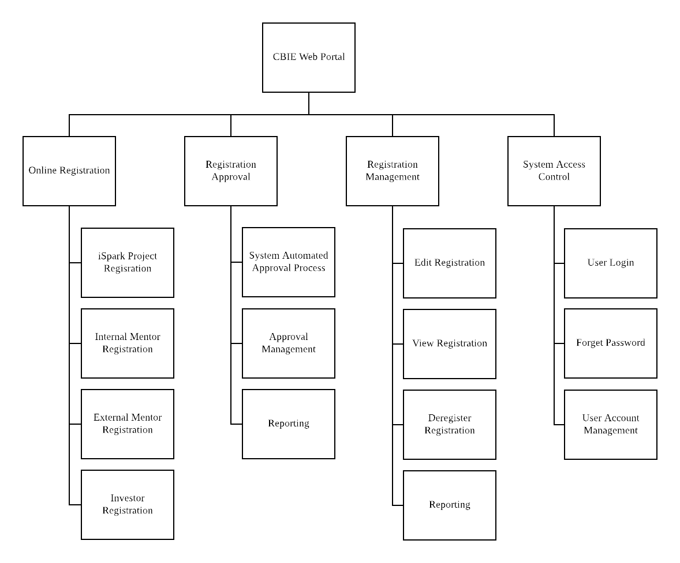

* + 1. Online Registration
       1. Project Registration

This module includes an online registration form for iSpark Project Registration. It contains a registration form and post processing includes client site form validation, server site validation and registration saving. In addition, registrant will receive a registration confirmation email and CBIEV staff will receive notification after a successful registration.

* + - * 1. Module Chart

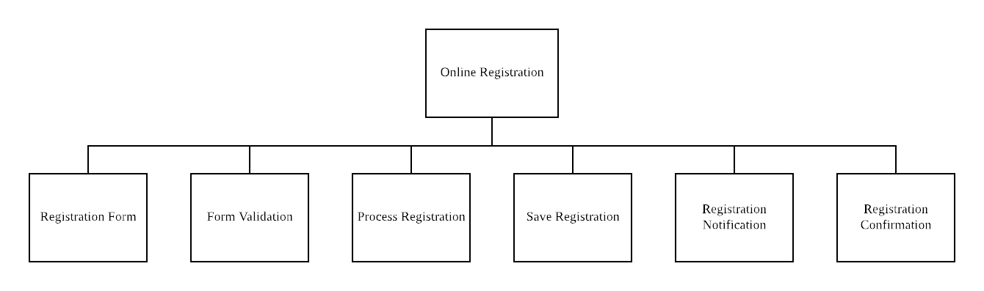

* + - * 1. Flow Chart

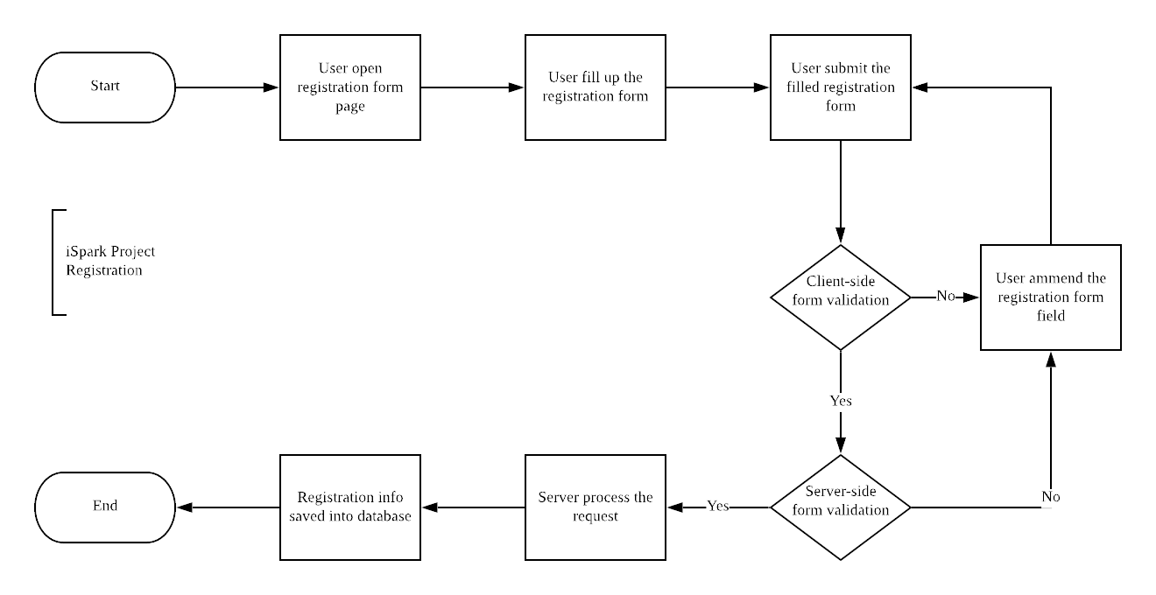

* + - * 1. Registration Form

This module includes an online registration form for Internal Mentor Registration. It contains a registration form and post processing includes client site form validation, server site validation and registration saving. In addition, registrant will receive a registration confirmation email and CBIEV staff will receive notification after a successful registration.

* + - * 1. Form Validation

This module includes an online registration form for Internal Mentor Registration. It contains a registration form and post processing includes client site form validation, server site validation and registration saving. In addition, registrant will receive a registration confirmation email and CBIEV staff will receive notification after a successful registration.

* + - * 1. Process Registration

This module includes an online registration form for Internal Mentor Registration. It contains a registration form and post processing includes client site form validation, server site validation and registration saving. In addition, registrant will receive a registration confirmation email and CBIEV staff will receive notification after a successful registration.

* + - 1. Registration Approval Process

This module handles all the approval processes for project registration. It will enable CBIEV staff to initiate the approval process, then invitation will send to involved person through email. In the sent email, it contains a temporary link that will redirect user to recommendation or approval form. The form will be validated both client and server-side before processing. After a successful recommendation/approval process, the system will notify CBIEV staff. Auto approve is to reduce the time for the recommendation process, after a fixed amount of time, the system will automatically ‘approve’ the recommendation and proceed to next stage.

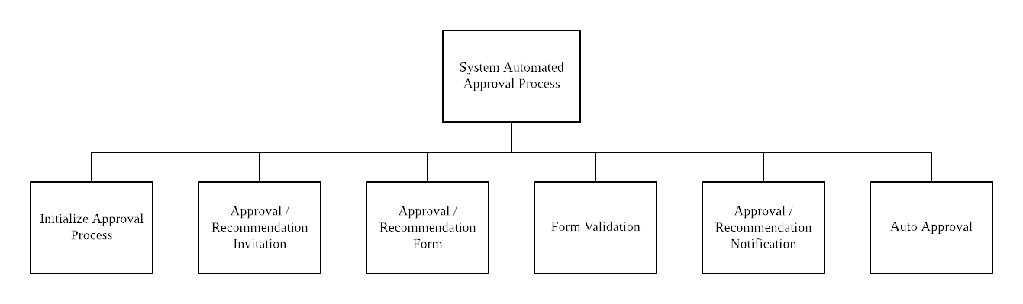

* + - * 1. Flow Chart

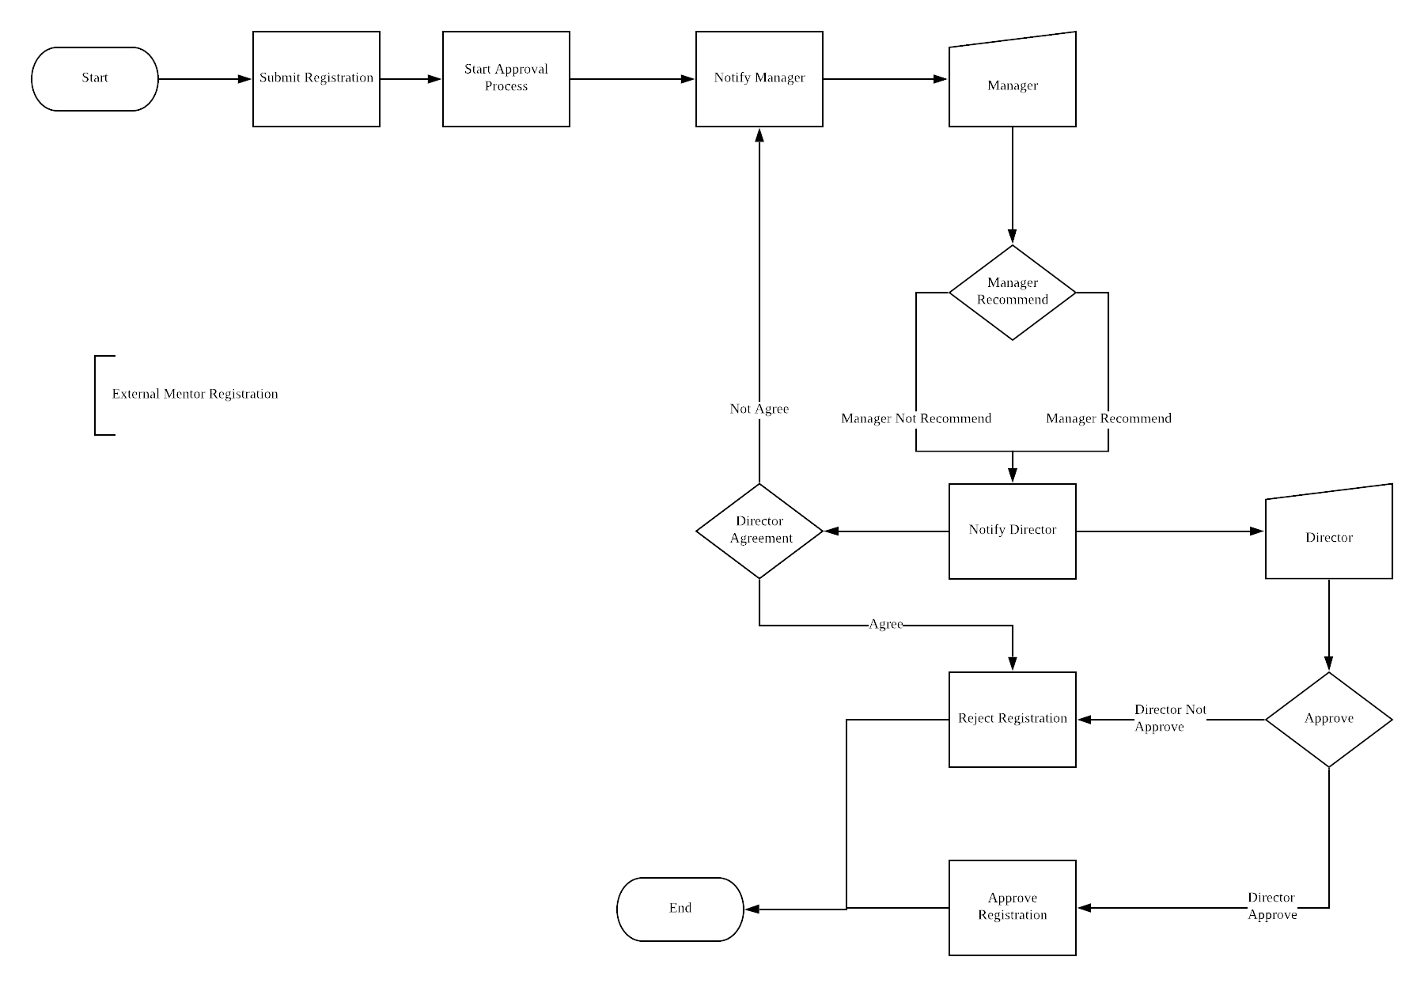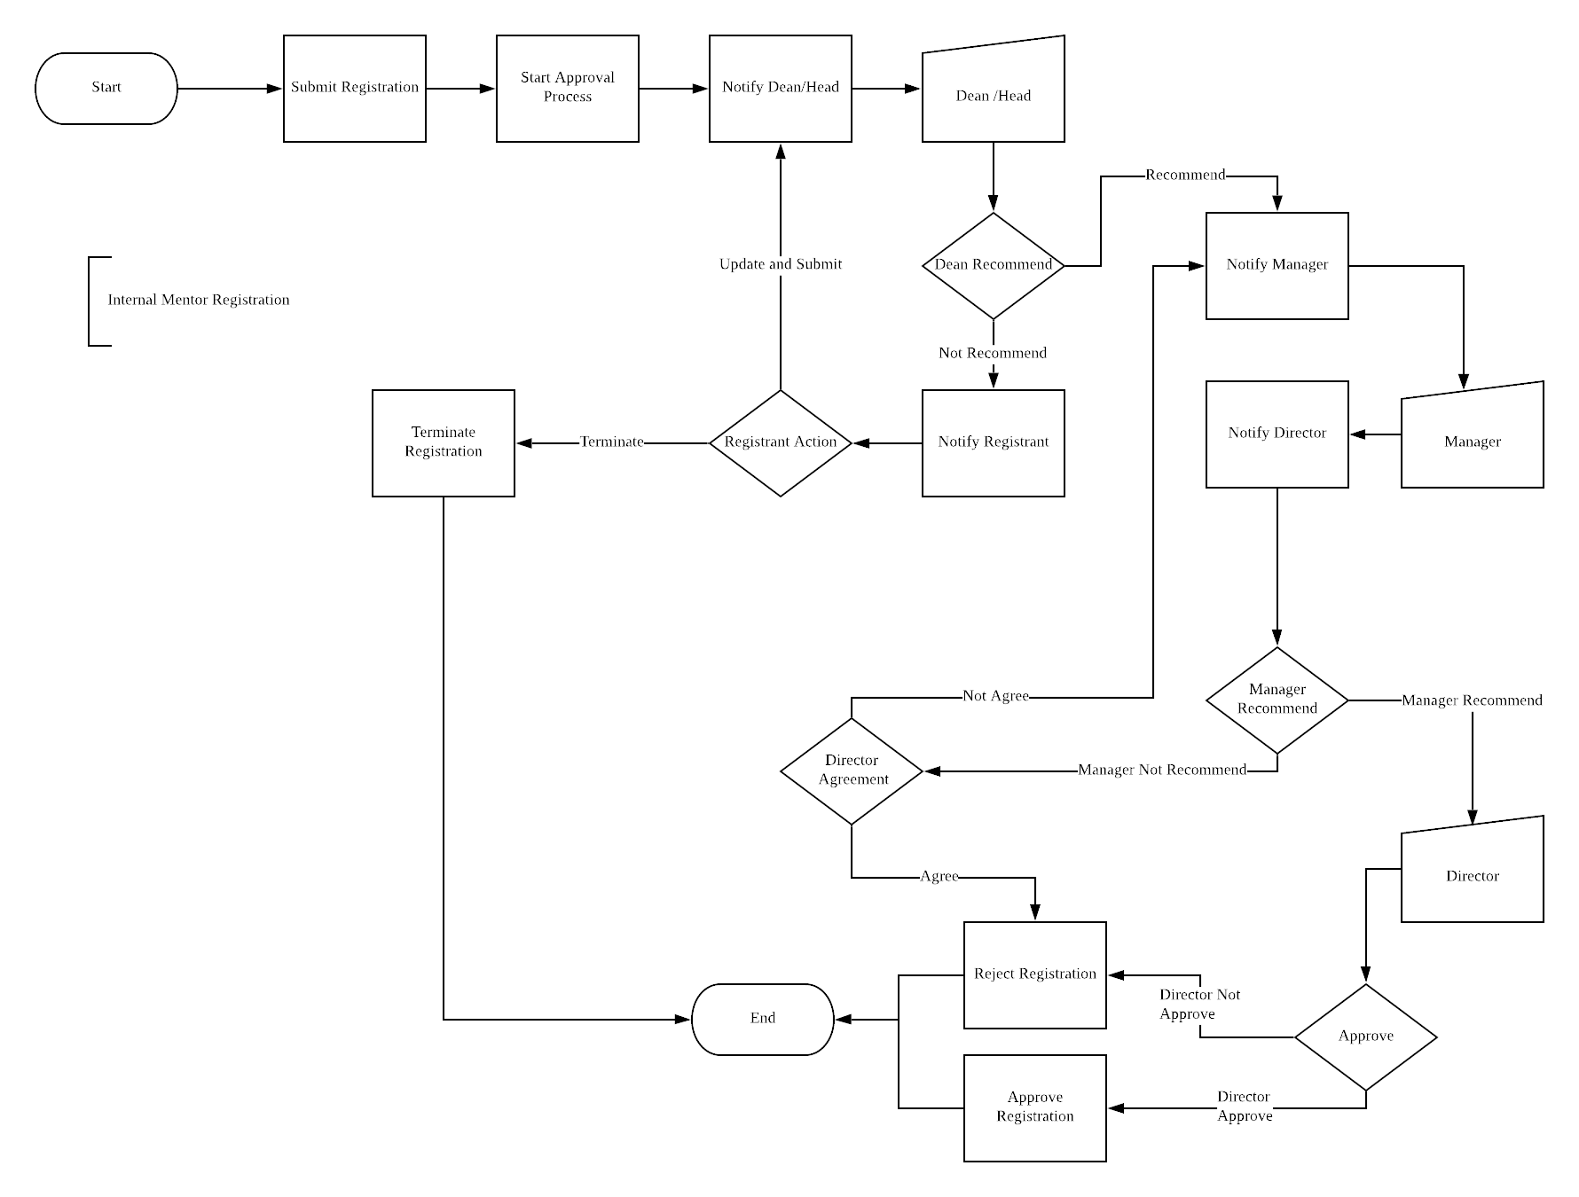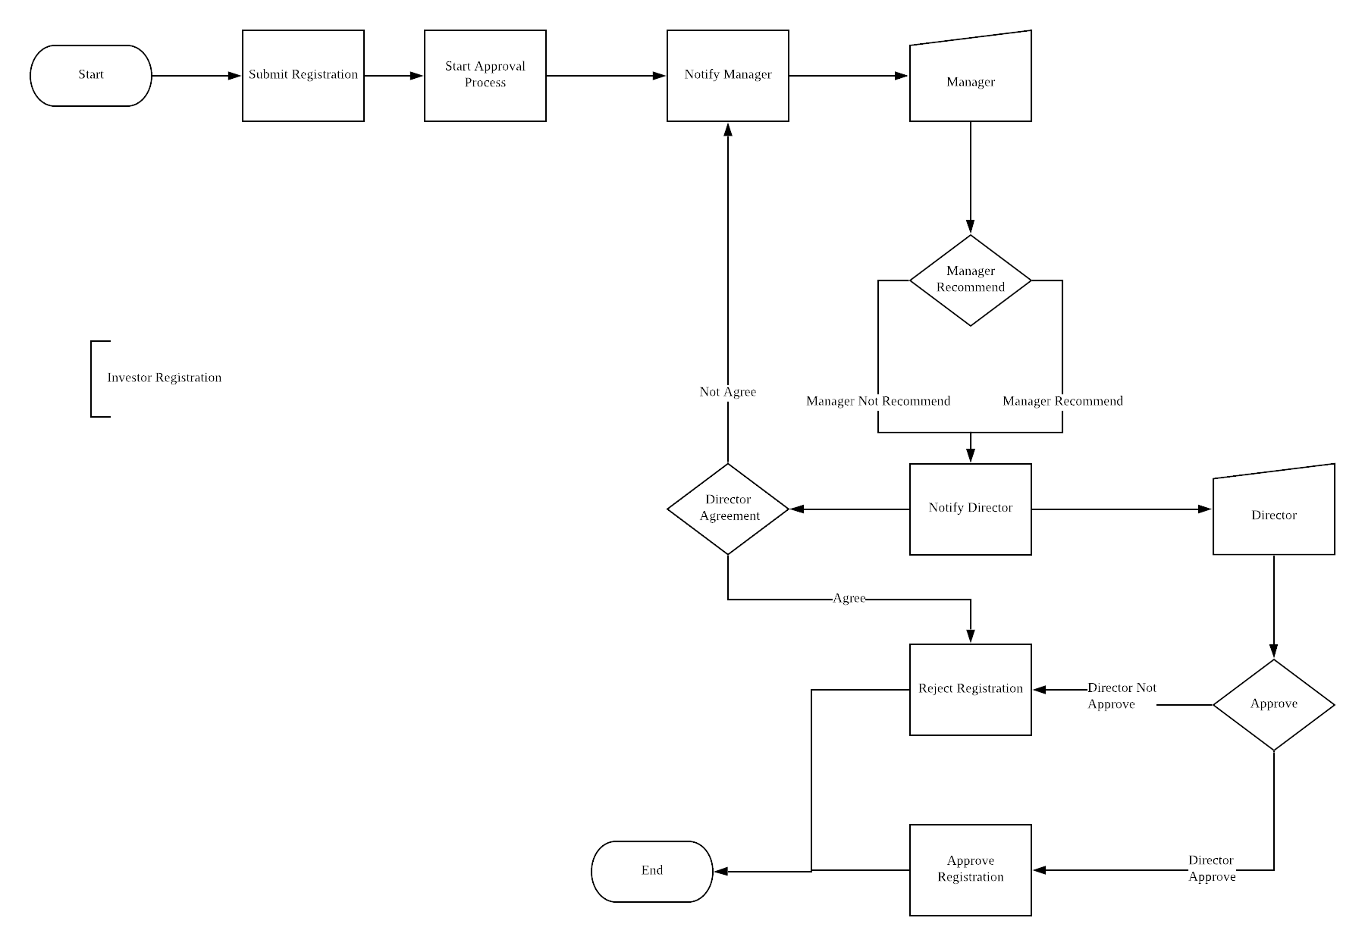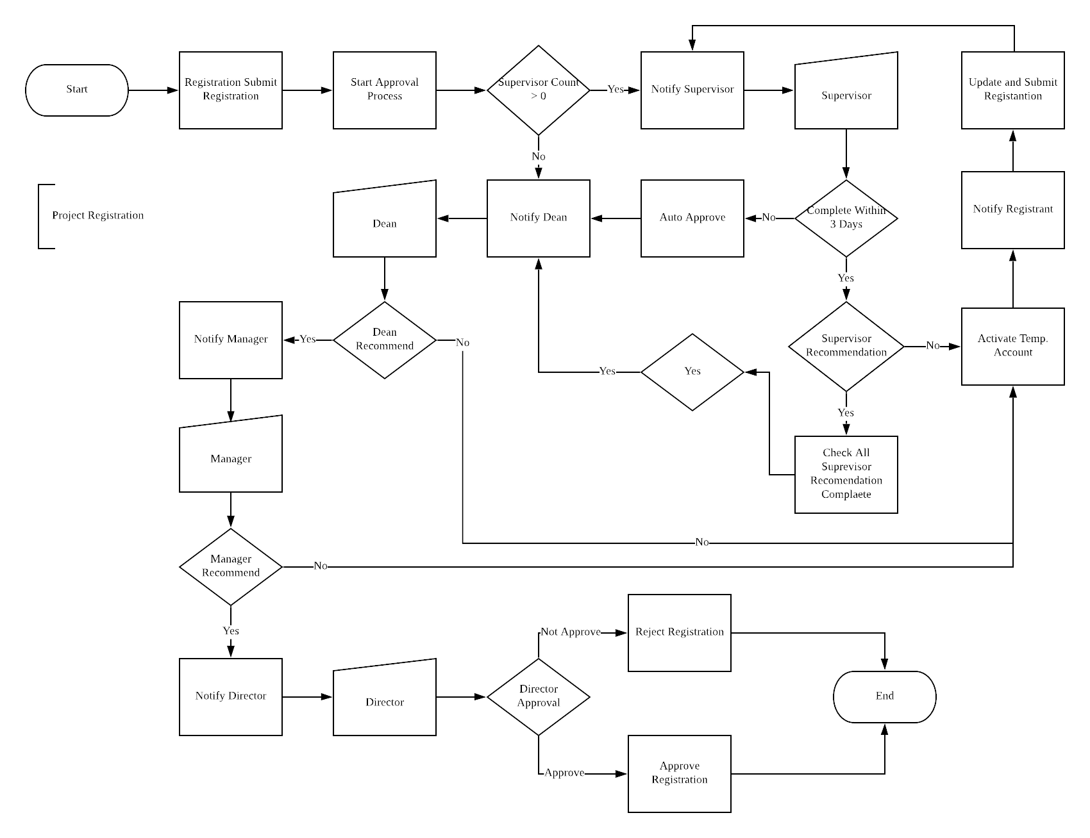

* + - * 1. Initialize Approval Process

This module handles all the approval processes for project registration. It will enable CBIEV staff to initiate the approval process, then invitation will send to involved person through email. In the sent email, it contains a temporary link that will redirect user to recommendation or approval form. The form will be validated both client and server-side before processing. After a successful recommendation/approval process, the system will notify CBIEV staff. Auto approve is to reduce the time for the recommendation process, after a fixed amount of time, the system will automatically ‘approve’ the recommendation and proceed to next stage.

* + - * 1. Approval/Recommendation Invitation

This module handles all the approval processes for project registration. It will enable CBIEV staff to initiate the approval process, then invitation will send to involved person through email. In the sent email, it contains a temporary link that will redirect user to recommendation or approval form. The form will be validated both client and server-side before processing. After a successful recommendation/approval process, the system will notify CBIEV staff. Auto approve is to reduce the time for the recommendation process, after a fixed amount of time, the system will automatically ‘approve’ the recommendation and proceed to next stage.

* + - * 1. Approval/Recommendation Form

This module handles all the approval processes for project registration. It will enable CBIEV staff to initiate the approval process, then invitation will send to involved person through email. In the sent email, it contains a temporary link that will redirect user to recommendation or approval form. The form will be validated both client and server-side before processing. After a successful recommendation/approval process, the system will notify CBIEV staff. Auto approve is to reduce the time for the recommendation process, after a fixed amount of time, the system will automatically ‘approve’ the recommendation and proceed to next stage.

* + - * 1. Form Validation

This module handles all the approval processes for project registration. It will enable CBIEV staff to initiate the approval process, then invitation will send to involved person through email. In the sent email, it contains a temporary link that will redirect user to recommendation or approval form. The form will be validated both client and server-side before processing. After a successful recommendation/approval process, the system will notify CBIEV staff.

* + - 1. Registration Management

This module includes management capabilities such as view and deregister for CBIEV staff. CBIEV staff will be able to view the list of registrations and details of each registration. In addition, CBIEV staff will be able to deregister registration.

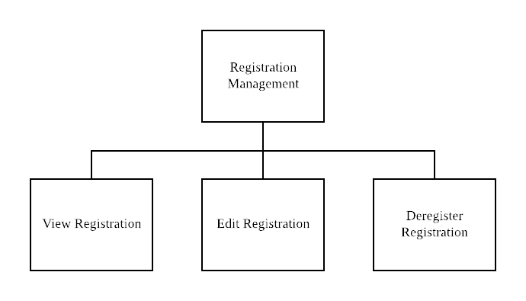

* + - 1. System Access Control

This module will include user account management to allow CBIEV to manage all the existing account in the system. Next, login function is implemented to prevent anonymous access, forgot password function is also included to allow user to reset their account password. In addition, an access control management is to manage the accessibility for each users and their respective role.

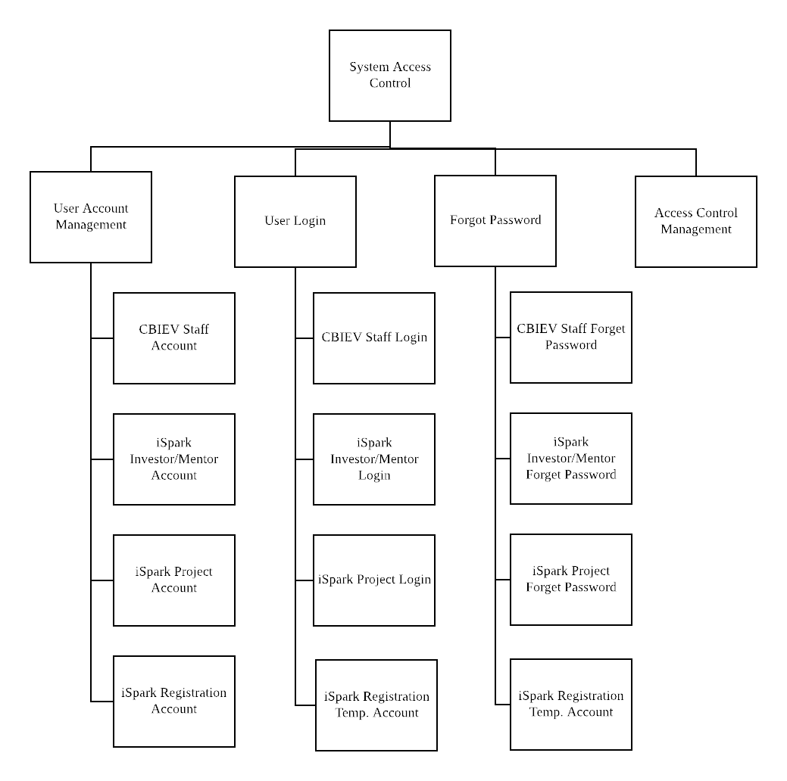

## Database Design

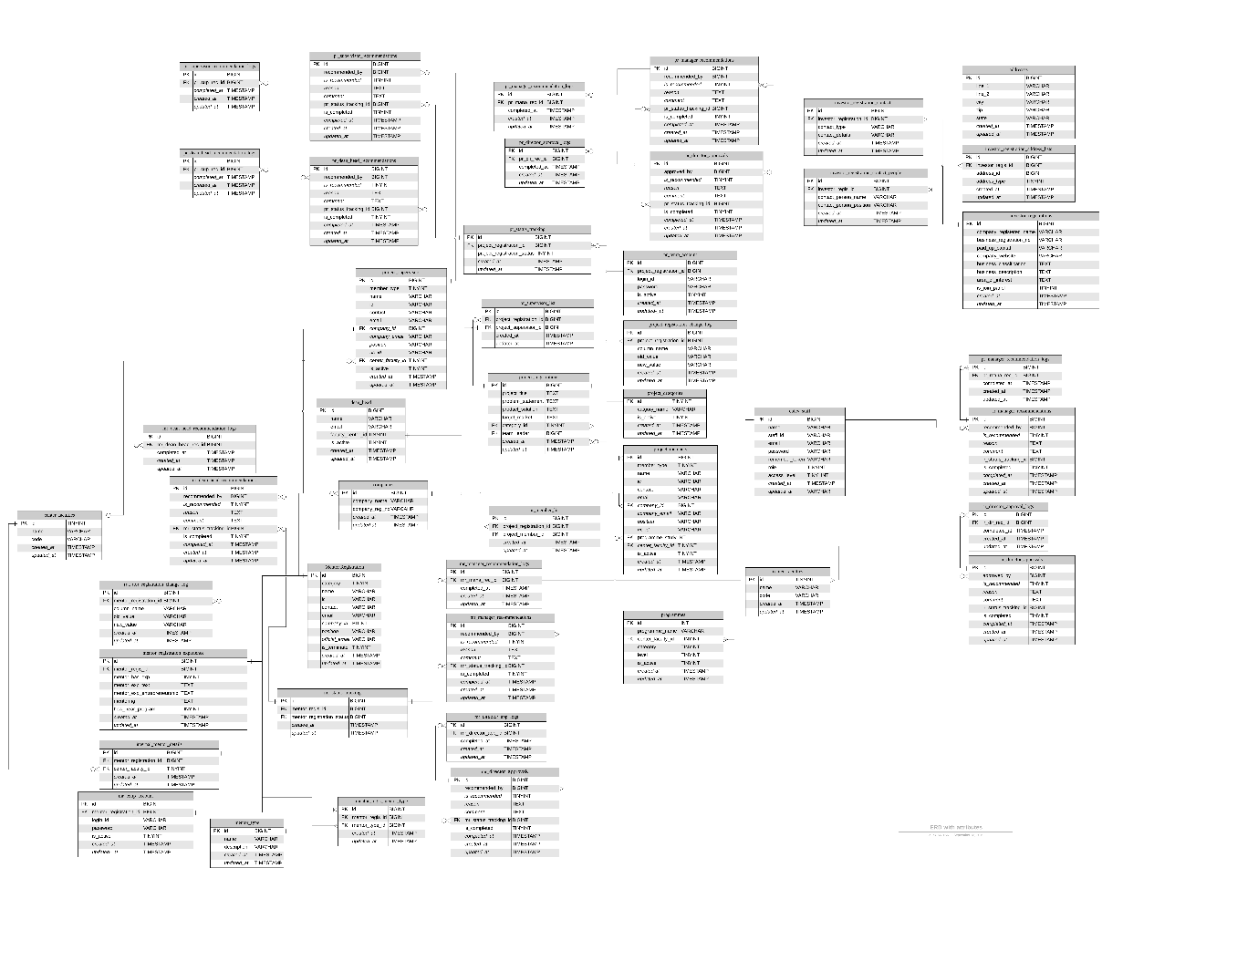

Note:

1. The original image is at the diagram/database directory.

2. Database tables and attributes document is attached as appendix.

# Future Upgrade/Consideration

# Development Environment/Deployment

## Software Environment

|  |  |
| --- | --- |
| Category | Tools |
| OS Environment | Any version of Windows or Linux operating system |
| Web Service | WAMP Stack 7.3.9 (Use latest) |
| Database | MySQL Community Server – GPL 8.0.16 (Use latest) |
| Database Administration Tool | SQLYog Community (Use latest)  phpMyAdmin |
| Code Editor | Visual Code, Vim, Atom |
| Others | Composer – PHP package manager (Use latest) |

## Installation Guide

* + 1. Prerequisites
* The environment must fulfil the server requirements at <https://laravel.com/docs>

1. Environment Preparation

Always download and install the latest stable version of the software.

* 1. Download and install Composer from <https://getcomposer.org/>
  2. Download and install Node.js from <https://nodejs.org/en/>
  3. Download and install WAMP stack from <https://bitnami.com/stack/wamp/installer>

1. Install Laravel
   1. Open a console/terminal and run command composer global require laravel/installer
2. Install System
   1. Download the project source code from GitHub.
   2. Open a console/terminal and change directory to the project directory.
   3. Run composer update to update the package dependencies.
   4. Run npm install to install Vue.js packages and dependencies
3. Setup System
   1. Run php artisan key:generate to generate an application key.
4. Database Configuration
   1. Open the .env and configure database setting

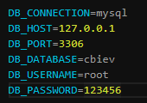

* 1. If you have a copy of database file, migrate the database into MySQL using phpMyAdmin.
  2. If you have no copy of database file, run php artisan notification:table, php artisan queue:table, php artisan queue:failed-table.
  3. Then migrate the query with php artisan migrate

1. Start Server
   1. Run php artisan serve to run the system on Apache.
   2. You may now browser the application at 127.0.0.1:8000

# Revision History

|  |  |  |  |  |
| --- | --- | --- | --- | --- |
| Date | Version | Author | Description | Author Signature |
| 23 Sep 2019 | 0.1-Draft | Tan Zi Xuan | Document Initial Release |  |
|  |  |  |  |  |
|  |  |  |  |  |
|  |  |  |  |  |
|  |  |  |  |  |
|  |  |  |  |  |
|  |  |  |  |  |
|  |  |  |  |  |
|  |  |  |  |  |
|  |  |  |  |  |
|  |  |  |  |  |
|  |  |  |  |  |
|  |  |  |  |  |
|  |  |  |  |  |
|  |  |  |  |  |
|  |  |  |  |  |
|  |  |  |  |  |

**Appendix**